**Project Title**:

MentorAI

**Project Summary:**

Our project, MentorAI, is an AI chatbot designed to act as a tutor for Computer Science students at UIUC. This AI tutor creates a customized learning experience by assessing each student’s level of understanding of certain topics based on their academic history, such as past exam scores. It evaluates their current understanding of the material and adjusts the difficulty and topics of practice problems to make learning more efficient. As students demonstrate improvement and consistency in grasping certain concepts, the tutor will begin making questions harder, or dial back the difficulty otherwise.

The AI tutor will use a large database of academic content, which will include practice problems, exams, as well as explanations of problems and concepts in order to adjust to students’ varying levels of understanding. It also provides a comprehensive learning experience by switching between topics and focusing on concepts that students have struggled the most with. The primary goal of MentorAI is to offer a personalized learning experience that caters to each student’s strengths and weaknesses, which is something that is otherwise often difficult to achieve in large classroom settings. With its chat-style interface, MentorAI encourages students to ask questions and interact with the tutor, making the learning process more engaging.

**Project Description:**

We intend to develop an AI Tutor that gives personalized academic support. We minted to focus particularly on college classes in the University of Illinois Computer Science Department.The Tutor will provide exact, personalized recommendation on content the student should go over, and new problems for students for the student to work on, based on their individual performance in past tests, quizzes, and homework assignments.

Our application will build a profile of the user's performance based on past academic data. This profile will allow the AI to adapt its suggestions and guidance, tailoring recommendations to areas where the student needs the most improvement. To achieve this, our system will integrate large language models (LLMs), leveraging retrieval-augmented generation (RAG) connected to a SQL database containing academic materials: including problem sets, study guides, and tutorials. Each resource in the database will be tied to a difficulty level, lesson from the class it comes from, etc, ensuring the AI can suggest problems and resources that are challenging and beneficial for the student’s current skill level. This whole system will be visualized in a chat-style interface that will allow the user to interact with the tutor as if it were a real human that they are texting.

The ultimate goal of this is to create a tutor that can provide comprehensive assistance to students beyond what chatgpt and other existing systems can provide on their own.

**Technically Challenging features:**

For the features we will build a progress tracker that could display the overall completion for students and what tasks they have left to complete – ‘Completion Dashboard’. Which will essentially be a visual representation of tasks completed, in progress, and yet to be started. The dashboard will show performance indicators using real-time data visualization techniques. We will create interactive charts and graphs in response to the student’s progress using packages such as Plotly, D3.js, and WebGL. Alongside, a study plan for more task’s organization. The study plan will dynamically change according to tasks that have more of a priority (based on deadlines, and difficulty of the task). Additionally, we will implement group study session to increase engagement. Groups will be forms according to the performance data and skill level – students that have a matched understanding level.

**Usefulness:**

While there are other educational resources and chatbots similar to MentorAI such as ChatGPT and Khan Academy, these applications lack the personalization and adaptiveness that MentorAI provides. Students may also require additional help and guidance outside the classroom that is tailored to their strengths and weaknesses, which makes our AI tutor all the more useful to Computer Science students. Our website is specifically designed to adjust to students’ needs, unlike other platforms. With features such as a chat-based interface, real-time difficulty level adjustments, and immediate feedback and explanations, MentorAI offers a more engaging and interactive learning experience.

**Realness**:

​​Chatbot AI Q and A Dataset - The dataset is sourced from Kaggle, and is specifically designed for training chatbots in question-answering tasks. The dataset is provided in CSV format, The dataset contains approximately 502 rows that answers a question. This dataset training data our AI model to make it understand and generate responses to general questions, enhancing the natural language understanding (NLU) component of our system.

Data Science Interview Q and A Treasury- This dataset is sourced from Kaggle, this dataset compiles a comprehensive set of interview questions and answers specifically focused on data science topics. The dataset is provided in CSV format and contains around 166 rows, each row representing a unique interview question along with an answer. This dataset captures a set of data science-related questions covering topics like machine learning, data analysis, Python programming, and statistical concepts. This dataset will be used to build a specialized module within the AI Tutor that focuses on data science topics, allowing students to learn and ask questions.

Stack Overflow Python Questions Dataset- This dataset is obtained from Kaggle and contains questions related to Python programming from Stack Overflow. The dataset is available in CSV format. It consists of 497 rows representing various questions and answers on Python topics.

[Chatbot](https://www.kaggle.com/datasets/yapwh1208/chatbot-ai-q-and-a), [Data Science Interview Q and A Treasury](https://www.kaggle.com/datasets/memocan/data-science-interview-q-and-a-treasury), [Stack Overflow Python Questions Dataset](https://www.kaggle.com/datasets/stackoverflow/pythonquestions/data)

**Functionality:**

1. **Users sign up-** The website would start off with the users sign up, and their performance data is initialized.

2. **Progress Tracker-** They can immediately access their personalized dashboard. Through the progress tracker, students interact with tasks, completing them, setting priorities, and adjusting study plans.

3. **Group Study Session-** Additionally, the students join group study sessions that align with their current learning needs, adapts the session based on group dynamics.

4. **Q & A-** We finally then have a Q & A integration where a chat interface allows users to ask questions at any time, receiving immediate feedback, guidance, and recommendations for further study.

**User Interactions**:

* 1. **Create**: Create users for logging in. Students can request new study sessions on specific topics or join existing ones that match their skill level, also add new tasks to their study plan.
  2. **Update**: Modify the tasks that they wish to complete, or have completed
  3. **Delete**: Delete tasks that they wish not to complete.
  4. **Search**: Search users that have logged in.

**Project Work Distribution:**

* Shreya Sharma - Will be responsible for frontend development and designing the chat-interface and progress tracker.
* Shreya Kalyanasundaram - Will be responsible for backend development and integrating all datasets and implementing CRUD operations.
* Philip Montgomery - Will be responsible for developing algorithms to handle progress tracking and real-time difficulty and topic adjustment.

**Low-fidelity UI mockup:**

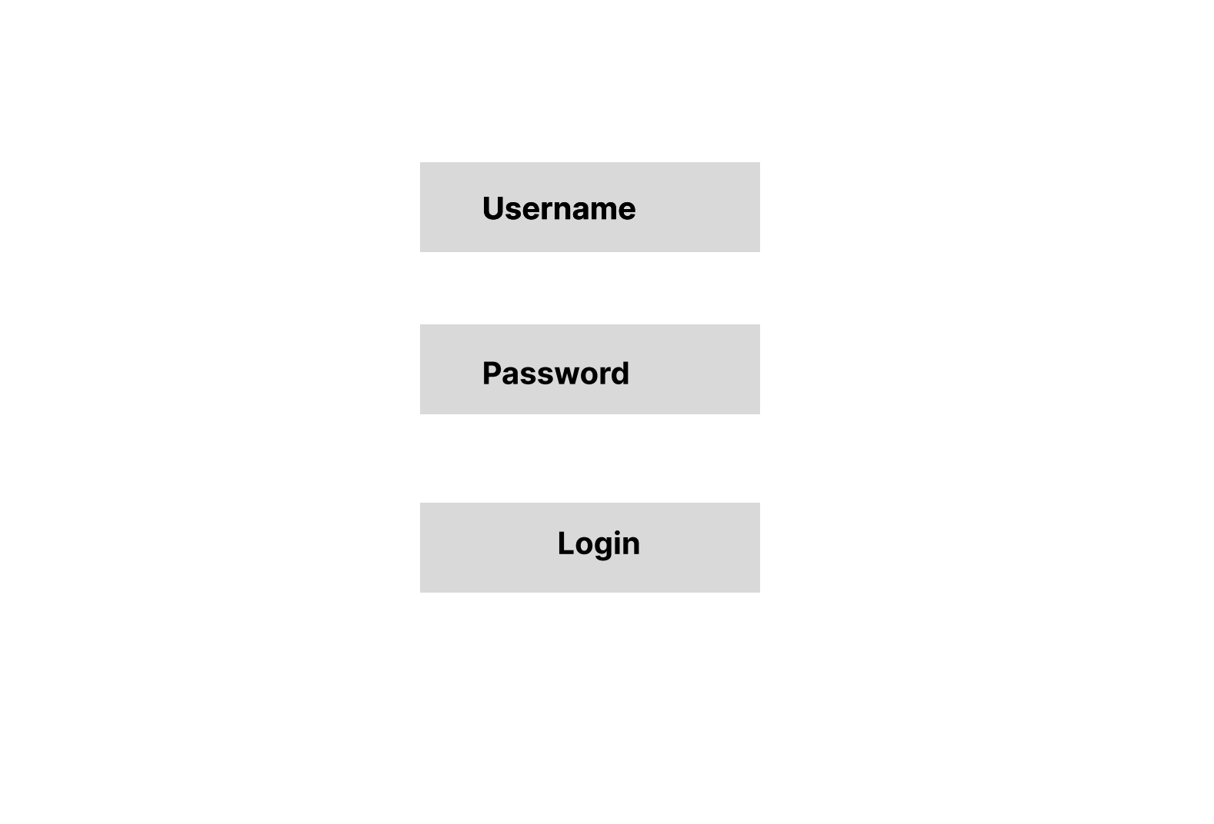

Figure 1. Login Page

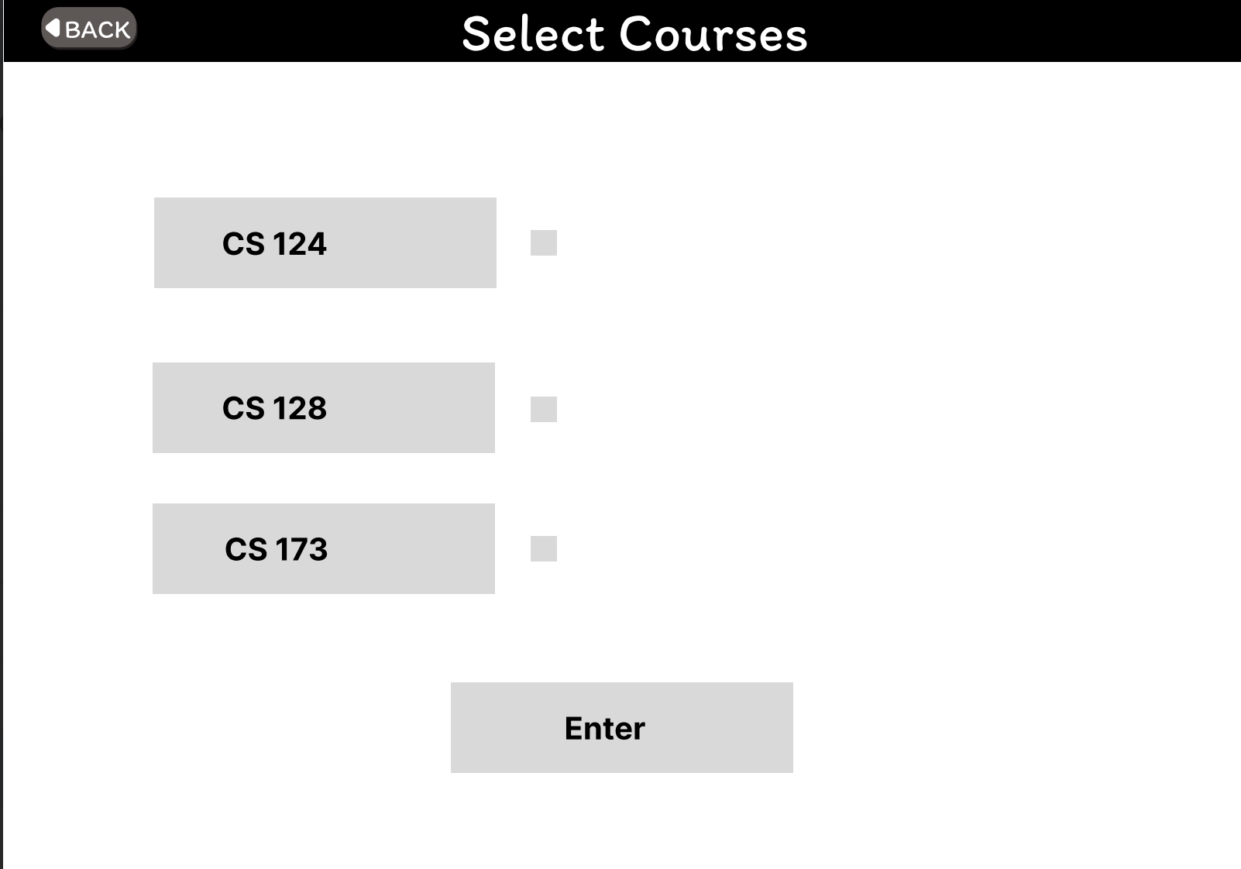

Figure 2. Course Selection Page

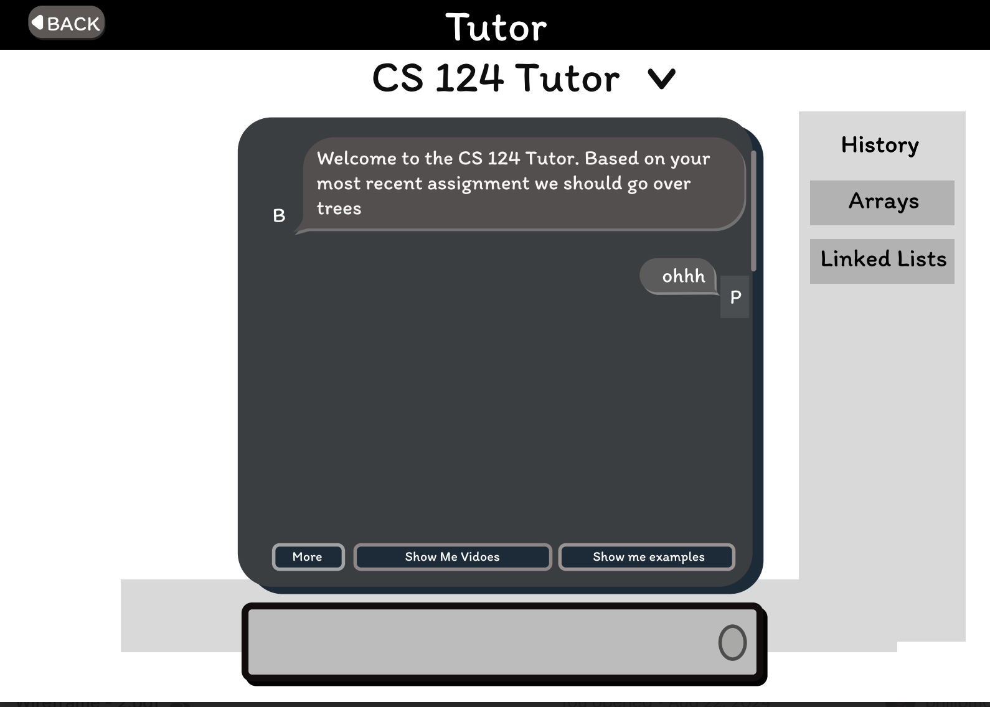

Figure 3. AI Chat